**FitFlex: Your Personal Fitness Companion**

**Project Documentation**

ProjectTitle:FitFlex:YourPersonalFitnessCompanion

Team ID : NM2025TMID37174

**Team Leader:** Priyadharsini M & mpriyadharsini215@gmail.com

Team Members: Miruthula G & miruthula1113@gmail.com

TeamMembers:Shayana G & [shayanagee061@gmail.com](mailto:shayanagee061@gmail.com)

TeamMembers:Vasanthra M & vasanthramurugesan@gmail.com

**INTRODUCTION: FITFLEX: YOUR PERSONAL FITNESS COMPANION**

In the modern world, maintaining a consistent fitness routine can be challenging, particularly for students and young professionals who often juggle busy schedules. The increasing dependency on technology and sedentary lifestyles have led to numerous health issues, making it difficult for individuals to prioritize their well-being. Recognizing this gap, **FitFlex** was created as a mobile application designed to help users stay on track with their fitness goals, encouraging a more active lifestyle through technology.

FitFlex serves as a fitness companion that allows users to easily track their daily physical activities, including steps walked and calories burned. The app uses real-time data from mobile sensors to provide users with personalized workout suggestions, tailored to their fitness levels and objectives. With a clean, user-friendly interface, FitFlex makes fitness tracking engaging, accessible, and informative for anyone, whether they’re a beginner or experienced athlete.

Developed using **Flutter**, a cross-platform framework, FitFlex works seamlessly on both **Android** and **iOS** devices. It connects with **Google Fit API** to retrieve data from mobile sensors, enabling accurate step tracking and activity monitoring. The app’s backend is powered by **Firebase**, ensuring secure user authentication and data storage. To calculate calories burned, FitFlex uses basic metabolic formulas and **MET (Metabolic Equivalent of Task)** values, giving users real-time insights into their physical activities.

**SOURCE CODE:**

**Index html**

<!DOCTYPE html>

<html lang="en">

<head>

<meta charset="utf-8" />

<meta name="viewport" content="width=device-width,initial-scale=1" />

<title>FitFlex</title>

<style>

* { box-sizing: border-box; margin: 0; padding: 0; }

html { scroll-behavior: smooth; }

body {

font-family: Arial, sans-serif;

color: #fff;

min-height: 100vh;

background: url('images/background.jpg') no-repeat center center/cover fixed;

}

.overlay {

position: fixed; inset: 0;

background: rgba(0,0,0,0.6);

z-index: 0; pointer-events: none;

}

.page { position: relative; z-index: 1; }

nav {

display: flex; justify-content: space-between; align-items: center;

padding: 16px 28px;

background: rgba(0,0,0,0.55);

position: sticky; top: 0; z-index: 1000;

backdrop-filter: blur(4px);

}

.logo { font-weight: 700; color: #00ff99; }

.nav-links { display: flex; gap: 14px; align-items:center; }

.nav-links a {

color: #fff; text-decoration: none; font-weight: 600;

padding: 6px 10px; border-radius: 6px;

transition: color 0.25s, background 0.25s;

}

.nav-links a:hover { color: #000; background: rgba(0,255,153,0.12); }

header { text-align: center; padding: 90px 20px 60px; }

header h1 {

font-size: 2.8rem; color: #00ff99;

text-shadow: 0 0 10px rgba(0,255,153,0.12), 0 0 30px rgba(0,255,153,0.06);

margin-bottom: 10px;

}

header p { font-size: 1.05rem; color: #dfeee7; opacity: 0.9; }

section { padding: 60px 20px; max-width: 1100px; margin: 0 auto; }

h2 { color: #00ff99; margin-bottom: 16px; text-align: center; }

.category-buttons { display:flex; gap: 10px; flex-wrap:wrap; justify-content:center; margin-top:12px; }

.category-buttons button {

background: rgba(255,255,255,0.06); color: #fff;

padding: 10px 14px; border-radius: 10px; border: 1px solid rgba(0,255,153,0.12);

cursor: pointer; font-weight:700;

transition: transform .18s, background .18s, color .18s;

}

.category-buttons button:hover { transform: translateY(-4px); }

.category-buttons button.active { background: #00ff99; color: #000; }

.workout-grid {

display: grid; grid-template-columns: repeat(auto-fit,minmax(220px,1fr));

gap: 20px; margin-top: 20px;

}

.workout-card {

perspective: 1100px;

opacity: 0; transform: translateY(16px);

transition: opacity .45s ease, transform .45s ease;

}

.workout-card.show { opacity: 1; transform: translateY(0); }

.card-inner {

width: 100%; height: 270px;

border-radius: 12px; position: relative;

transform-style: preserve-3d; transition: transform .8s cubic-bezier(.2,.9,.3,1);

cursor: pointer; box-shadow: 0 6px 18px rgba(0,0,0,0.45);

}

.card-inner.flip { transform: rotateY(180deg); }

.card-face {

position: absolute; inset: 0; backface-visibility: hidden; border-radius: 12px;

overflow: hidden; display:flex; flex-direction: column; align-items: center; justify-content: center;

text-align: center; padding: 18px;

}

.card-front { background: rgba(0,0,0,0.45); }

.card-front img { width: 100%; height: 160px; object-fit: cover; }

.card-front h3 { margin-top: 10px; color: #00ff99; }

.card-back {

transform: rotateY(180deg);

background: linear-gradient(180deg, rgba(5,5,5,0.9), rgba(10,10,10,0.95));

color: #e9fff3;

}

.card-back h4 { color: #00ff99; margin-bottom: 8px; }

.card-back p { font-size: .95rem; color: #d7f9e7; }

.plans-container {

display: flex;

flex-wrap: wrap;

gap: 24px;

justify-content: center;

margin-top: 30px;

}

.plan-box {

background: rgba(255,255,255,0.08);

border-radius: 12px;

padding: 24px;

max-width: 280px;

text-align: center;

border: 2px solid #00ff99;

}

.plan-box h3 { color: #00ff99; margin-bottom: 12px; }

.plan-box p { color: #d2fbe9; margin-bottom: 12px; }

.plan-box h4 { color: #fff; margin-bottom: 14px; }

.plan-box button {

background: #00ff99;

color: #000;

border: none;

padding: 10px 18px;

border-radius: 6px;

font-weight: bold;

cursor: pointer;

}

.fav-btn, .remove-fav-btn {

margin-top: 8px;

background: transparent;

border: none;

font-size: 1.3rem;

cursor: pointer;

transition: transform 0.2s;

}

.fav-btn { color: #ff4d6d; }

.fav-btn:hover, .remove-fav-btn:hover { transform: scale(1.2); }

.remove-fav-btn { color: #ff6666; font-size: 1.2rem; }

footer { text-align:center; padding: 28px 20px; color: #b6f6d7; margin-top: 40px; }

</style>

<script>

if (localStorage.getItem("isLoggedIn") !== "true") {

window.location.href = "login.html";

}

</script>

</head>

<body>

<div class="overlay"></div>

<div class="page">

<nav>

<div class="logo">🏋️ FitFlex</div>

<div class="nav-links">

<a href="#home">Home</a>

<a href="#workouts">Workouts</a>

<a href="#plans">Plans</a>

<a href="#favorites">Favorites</a>

<a href="#blog">Blog</a>

<a href="#contact">Contact</a>

<a href="#" onclick="logout()" style="color: #ff6666;">Logout</a>

</div>

</nav>

<header id="home">

<h1>Push Yourself — Because No One Else Will</h1>

<p>Start today. Small consistent steps build strength and confidence.</p>

</header>

<section id="workouts">

<h2>Workout Categories</h2>

<div class="category-buttons">

<button data-cat="cardio">Cardio</button>

<button data-cat="dumbbell">Dumbbell</button>

<button data-cat="back">Back</button>

<button data-cat="chest">Chest</button>

</div>

<div class="workout-grid" id="workoutCards"></div>

</section>

<section id="favorites">

<h2>Your Favorite Workouts</h2>

<div class="workout-grid" id="favoriteCards"></div>

</section>

<section id="plans">

<h2>Choose Your Plan</h2>

<div class="plans-container">

<div class="plan-box">

<h3>Free</h3>

<p>✔️ Basic workouts<br>✔️ Blog access</p>

<h4>$0 / month</h4>

<button>Current Plan</button>

</div>

<div class="plan-box">

<h3>Premium</h3>

<p>✔️ All workouts<br>✔️ Progress tracking</p>

<h4>$9.99 / month</h4>

<button onclick="openPlanForm()">Upgrade</button>

</div>

<div class="plan-box">

<h3>Elite</h3>

<p>✔️ Premium + Coaching<br>✔️ Custom meal plan</p>

<h4>$19.99 / month</h4>

<button onclick="openPlanForm()">Go Elite</button>

</div>

</div>

</section>

<section id="blog">

<h2>Blog & Motivation</h2>

<p style="text-align:center;">At FitFlex, we believe fitness is not just about the body—it’s about the mind too.

Our journey started with a single goal: to make workouts accessible to everyone.

Stay motivated, stay strong. Every rep brings you closer to your best self.</p>

</section>

<section id="contact">

<h2>Contact Us</h2>

<div style="text-align:center;">

<p>📧 Email: <a href="mailto:fitflex@gmail.com" style="color:#00ff99;">fitflex@gmail.com</a></p>

<p>📞 Phone: <a href="tel:+1234567890" style="color:#00ff99;">+1 (234) 567-890</a></p>

<p>📍 Address: 123 FitFlex Street, Muscle City, CA 90210</p>

</div>

</section>

<footer>&copy; 2025 FitFlex. Built with sweat & love.</footer>

</div>

<!-- PLAN MODAL -->

<div id="planModal" style="display:none; position:fixed; inset:0; background:rgba(0,0,0,0.7); justify-content:center; align-items:center; z-index:2000;">

<div style="background:#111; padding:30px; border-radius:12px; max-width:400px; width:90%; text-align:center; position:relative;">

<span id="closeModal" style="position:absolute; top:12px; right:16px; cursor:pointer; font-size:22px;">&times;</span>

<h3 style="color:#00ff99; margin-bottom:12px;">Subscribe to Plan</h3>

<form id="planForm" style="display:flex; flex-direction:column; gap:12px;">

<input type="text" name="name" placeholder="Your Name" required style="padding:10px; border-radius:6px; border:none;">

<input type="email" name="email" placeholder="Email Address" required style="padding:10px; border-radius:6px; border:none;">

<input type="tel" name="contact" placeholder="Contact Number" required style="padding:10px; border-radius:6px; border:none;">

<button type="submit" style="background:#00ff99; color:#000; padding:10px; border:none; border-radius:6px; font-weight:bold; cursor:pointer;">Submit</button>

</form>

<p id="thankYou" style="color:#fff; margin-top:12px; display:none;">Thank you for subscribing!</p>

</div>

</div>

<!-- JS -->

<script>

const workouts = {

cardio: [

{ name: "Jumping Jacks", img: "images/jumping_jacks.jpg", details: "3 sets × 40 seconds — full-body cardio warm-up." },

{ name: "High Knees", img: "images/high_knees.jpg", details: "4 sets × 30 seconds — explosiveness & HIIT." },

{ name: "Mountain Climbers", img: "images/mountain_climbers.jpeg", details: "3 sets × 20 reps (each leg) — core & cardio." },

{ name: "Burpees", img: "images/burpees.jpg", details: "3 sets × 12 reps — full-body conditioning." }

],

dumbbell: [

{ name: "Bicep Curls", img: "images/bicep_curls.jpg", details: "4 sets × 10–12 reps — isolate biceps." },

{ name: "Dumbbell Squats", img: "images/dumbell_squats.jpg", details: "3 sets × 12–15 reps — legs & core." },

{ name: "Dumbbell Lunges", img: "images/dumbbell_lunges.jpg", details: "3 sets × 10 reps/leg — unilateral strength." },

{ name: "Shoulder Press", img: "images/shoulder_press.jpg", details: "4 sets × 8–10 reps — shoulder strength." }

],

back: [

{ name: "Pull-Ups", img: "images/pull_ups.jpg", details: "4 sets × 6–10 reps — upper back & lats." },

{ name: "Bent Over Rows", img: "images/bent_over_rows.jpg", details: "4 sets × 8–12 reps — thickness & posture." },

{ name: "Lat Pulldown", img: "images/lat_pulldown.jpg", details: "4 sets × 10 reps — lat width." },

{ name: "Deadlifts", img: "images/deadlift.jpg", details: "4 sets × 5–8 reps — full posterior chain." }

],

chest: [

{ name: "Push-Ups", img: "images/push_ups.jpg", details: "4 sets × 12–20 reps — bodyweight chest builder." },

{ name: "Bench Press", img: "images/bench_press.jpg", details: "4 sets × 6–10 reps — strength & size." },

{ name: "Chest Fly", img: "images/chest_fly.jpg", details: "3 sets × 10–12 reps — chest isolation." },

{ name: "Incline Press", img: "images/incline_press.jpg", details: "4 sets × 8–10 reps — upper chest focus." }

]

};

const container = document.getElementById('workoutCards');

const catButtons = document.querySelectorAll('.category-buttons button');

catButtons.forEach(btn => {

btn.addEventListener('click', () => {

const cat = btn.dataset.cat;

showCategory(cat);

catButtons.forEach(b => b.classList.remove('active'));

btn.classList.add('active');

});

});

function showCategory(cat) {

container.innerHTML = '';

(workouts[cat] || []).forEach((w, i) => {

const card = document.createElement('div');

card.className = 'workout-card';

card.innerHTML = `

<div class="card-inner">

<div class="card-face card-front">

<img src="${w.img}" alt="${w.name}">

<h3>${w.name}</h3>

<button class="fav-btn" data-name="${w.name}">❤️</button>

</div>

<div class="card-face card-back">

<h4>${w.name}</h4>

<p>${w.details}</p>

</div>

</div>

`;

container.appendChild(card);

setTimeout(() => card.classList.add('show'), i * 120);

card.querySelector('.card-inner').addEventListener('click', e => {

e.currentTarget.classList.toggle('flip');

});

card.querySelector('.fav-btn').addEventListener('click', e => {

e.stopPropagation();

addToFavorites(w);

});

});

}

function getFavorites() {

return JSON.parse(localStorage.getItem("favoriteWorkouts") || "[]");

}

function saveFavorites(favs) {

localStorage.setItem("favoriteWorkouts", JSON.stringify(favs));

}

function addToFavorites(workout) {

let favs = getFavorites();

if (!favs.find(f => f.name === workout.name)) {

favs.push(workout);

saveFavorites(favs);

alert(`${workout.name} added to favorites!`);

showFavorites();

}

}

function showFavorites() {

const favs = getFavorites();

const favContainer = document.getElementById("favoriteCards");

favContainer.innerHTML = "";

if (favs.length === 0) {

favContainer.innerHTML = "<p style='text-align:center; color:#ccc;'>No favorites yet.</p>";

return;

}

favs.forEach((w, i) => {

const card = document.createElement('div');

card.className = 'workout-card';

card.innerHTML = `

<div class="card-inner">

<div class="card-face card-front">

<img src="${w.img}" alt="${w.name}">

<h3>${w.name}</h3>

<button class="remove-fav-btn" data-name="${w.name}">❌</button>

</div>

<div class="card-face card-back">

<h4>${w.name}</h4>

<p>${w.details}</p>

</div>

</div>

`;

favContainer.appendChild(card);

setTimeout(() => card.classList.add('show'), i * 120);

card.querySelector('.card-inner').addEventListener('click', e => {

e.currentTarget.classList.toggle('flip');

});

card.querySelector('.remove-fav-btn').addEventListener('click', e => {

e.stopPropagation();

removeFavorite(w.name);

});

});

}

function removeFavorite(name) {

let favs = getFavorites().filter(f => f.name !== name);

saveFavorites(favs);

showFavorites();

}

function openPlanForm() {

document.getElementById('planModal').style.display = 'flex';

}

document.getElementById('closeModal').onclick = () => {

document.getElementById('planModal').style.display = 'none';

};

document.getElementById('planForm').onsubmit = function(e) {

e.preventDefault();

document.getElementById('thankYou').style.display = 'block';

this.reset();

setTimeout(() => {

document.getElementById('planModal').style.display = 'none';

document.getElementById('thankYou').style.display = 'none';

}, 2000);

};

function logout() {

localStorage.removeItem("isLoggedIn");

window.location.href = "login.html";

}

window.addEventListener("load", () => {

catButtons[0].click(); // Default: show first category

showFavorites(); // Load favorites on page load

});

</script>

</body>

</html>

**Login html**

**<!DOCTYPE html>**

**<html lang="en">**

**<head>**

**<meta charset="UTF-8">**

**<meta name="viewport" content="width=device-width, initial-scale=1.0">**

**<title>Login - FitFlex</title>**

**<style>**

**body {**

**margin: 0;**

**font-family: Arial, sans-serif;**

**background: url('images/background.jpg') no-repeat center center/cover;**

**background-attachment: fixed;**

**color: #fff;**

**}**

**body::before {**

**content: '';**

**position: fixed;**

**top: 0; left: 0;**

**width: 100%; height: 100%;**

**background: rgba(0,0,0,0.7);**

**z-index: -1;**

**}**

**.login-container {**

**width: 300px;**

**margin: 100px auto;**

**background: rgba(20,20,20,0.9);**

**padding: 20px;**

**border-radius: 12px;**

**text-align: center;**

**}**

**h2 { margin-bottom: 20px; }**

**input {**

**width: 90%;**

**padding: 10px;**

**margin: 10px 0;**

**border: none;**

**border-radius: 6px;**

**}**

**button {**

**padding: 10px 20px;**

**background: #00ff99;**

**border: none;**

**border-radius: 6px;**

**cursor: pointer;**

**font-weight: bold;**

**}**

**button:hover { background: #00cc77; }**

**.back-home {**

**display: block;**

**margin-top: 15px;**

**color: #00ff99;**

**text-decoration: none;**

**}**

**.message {**

**margin-top: 15px;**

**font-weight: bold;**

**}**

**.success { color: #00ff99; }**

**.error { color: #ff4444; }**

**</style>**

**</head>**

**<body>**

**<div class="login-container">**

**<h2>Login</h2>**

**<form id="loginForm">**

**<input type="text" id="username" placeholder="Username" required><br>**

**<input type="password" id="password" placeholder="Password" required><br>**

**<button type="submit">Login</button>**

**</form>**

**<p id="message" class="message"></p>**

**<a href="index.html" class="back-home">← Back to Home</a>**

**</div>**

**<script>**

**const form = document.getElementById('loginForm');**

**const message = document.getElementById('message');**

**form.addEventListener('submit', function(e) {**

**e.preventDefault(); // prevent page refresh**

**const user = document.getElementById('username').value;**

**const pass = document.getElementById('password').value;**

**if (user === "admin" && pass === "1234") {**

**localStorage.setItem("isLoggedIn", "true"); // ✅ Save login status**

**window.location.href = "index.html"; // ✅ Redirect to main page**

**} else {**

**message.textContent = "Invalid Login!";**

**message.className = "message error";**

**}**

**});**

**</script>**

**<script>**

**const form = document.getElementById('loginForm');**

**const message = document.getElementById('message');**

**...**

**</script>**

**</body>**

**</html>**

**OUTPUT SCREENSHORT:**

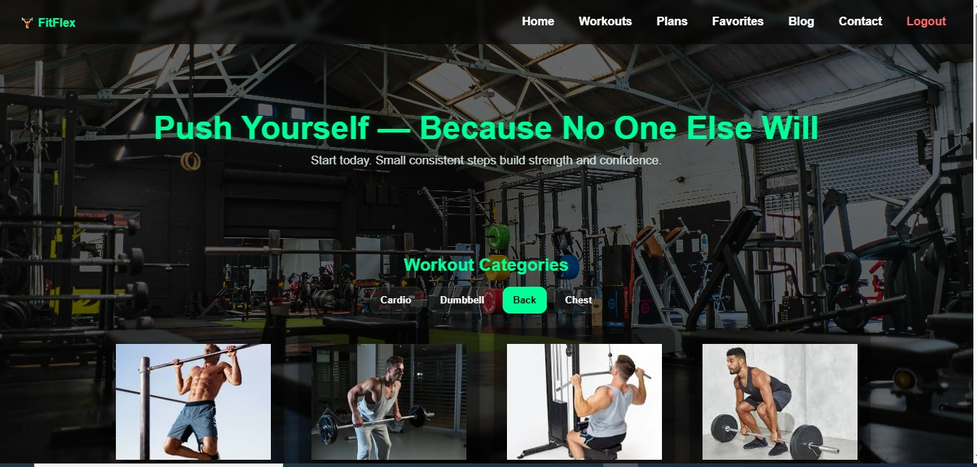

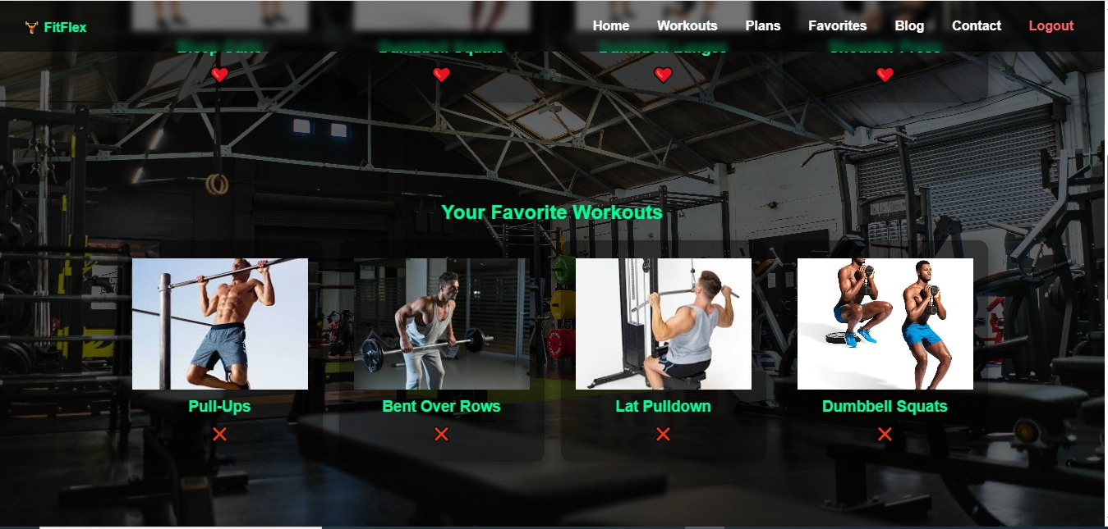

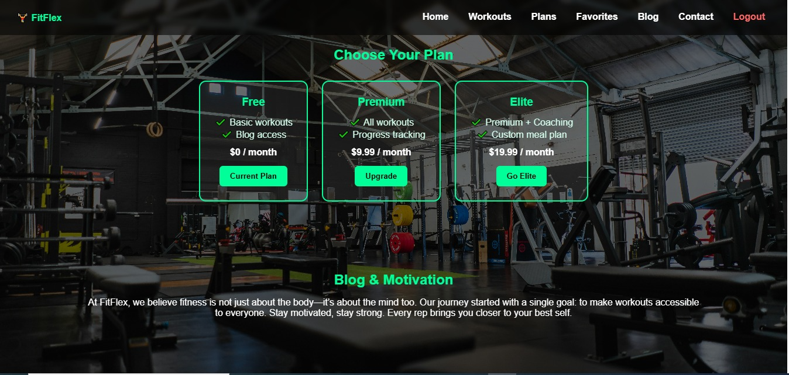

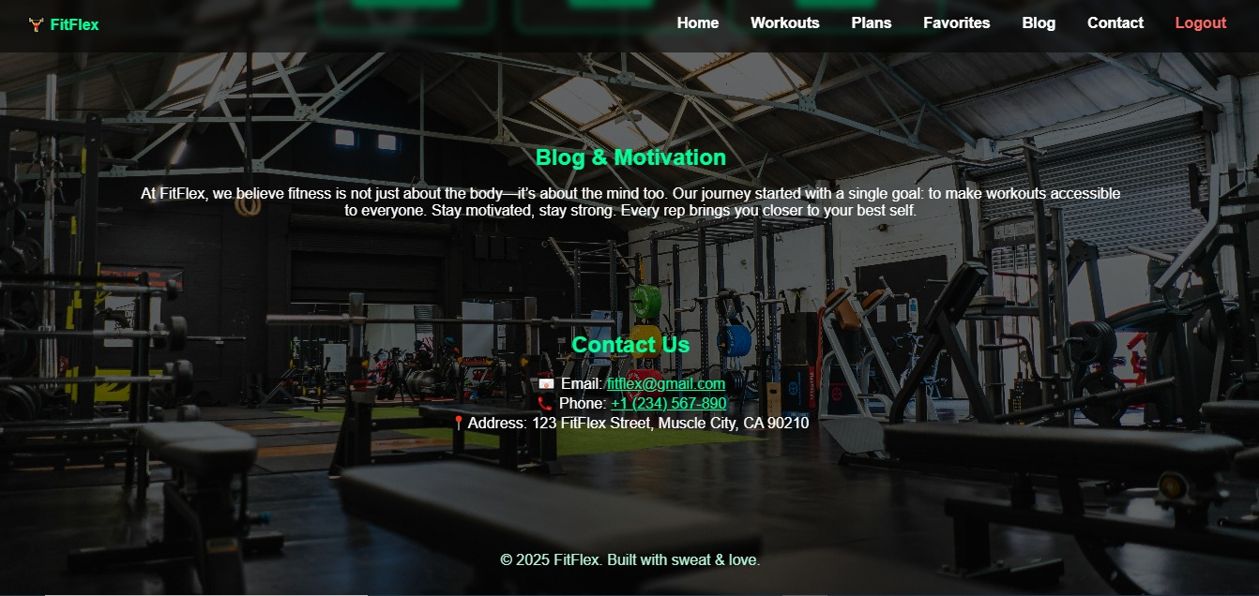

**CODE WEBSITE DEMO LINK:**

[**https://drive.google.com/file/d/1KOiqu5PAoyAdTNNqYM7nEWf9PmUqvxrE/view?usp=drivesdk**](https://drive.google.com/file/d/1KOiqu5PAoyAdTNNqYM7nEWf9PmUqvxrE/view?usp=drivesdk)